
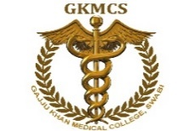
Medical Teaching Institute
GKMC/BKMC Swabi

Incident report form

Date of incident: Time_ Department:
Service name:

- What was the incident/near miss?

- Were there any injuries or death?

- Was There any damage to property?

- What caused the incident?

- What measures will be taken to eliminate future repeats of the incident?

- Recommendations
Recommendation from IT/MIS Department:

- Management Comments

Signed off by the management when corrective actions have been adopted and monitored.

Management Signature___________________________ Date of sign off____________________

